Sheet Cost – Below the Minimum Size Charges:

The “Under Width” and “Under Length” adders are used to automatically add the additional fees that the sheet plant’s board vendors charge for short blank sizes. These additional charges can be applied by grade and by vendor (including the blank estimating vendor).

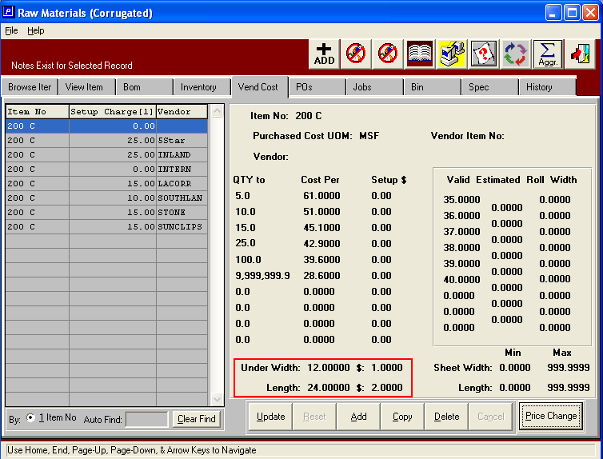

The additional charge for the small blank will be included in the board cost for the estimate (from the “blank” vendor or the selected vendor at estimate calculation time), and the additional charge for the specific actual vendor will be applied to the sheet purchase order.

